Table of Contents

Abstract 2

Dedication 2

Acknowledgements 2

List of Tables 2

List of Figures 2

Introduction 2

Software Architecture in Autonomous Vehicles 3

AutoDrive Challenge II 4

Thesis Overview 4

Background and Literature Review 5

Planning and control in Autonomous Vehicles 5

Global Path Planning 5

Decision making in AV 5

Control and vehicle maneuvering 5

Planning and control approaches 5

Classical Rule Based approaches 5

Optimization Based approaches 5

Learning Based approaches 5

Highway Lane Changing for Autonomous vehicles 5

Lane Changing Approaches 5

Rule Based Lane change decision making 7

Lane change problem formulation 7

Static Obstacle Lane Change 7

Dynamic Obstacle Lane Change 7

Lane Change Trajectory Generation 7

Lane Change in the presence of Icy/ Snowy Conditions 7

Artificial Potential Field Approach for Highway Lane Changing 8

Artificial Potential Fields (APF): 8

APF Analogy: 9

APF Drawbacks: 9

Improved APF for lane changing in autonomous vehicles in the presence of low friction surfaces: 10

Design requirements: 10

Road Potential: 10

Goal Potential: 11

Obstacle Potential: 11

Verification and Validation 12

Overview 12

Model in loop V&V 12

Overview and setup 13

Hardware in loop V&V 13

Overview and setup 13

# Abstract

# Dedication

# Acknowledgements

# List of Tables

# List of Figures

# Introduction

Autonomous vehicles, also known as self-driving cars, have been in development for many years. The first autonomous vehicles were developed in the 1980s and 1990s, but they were very basic and not capable of driving on public roads. In the early 2000s, more advanced autonomous vehicles began to be developed, and they were able to navigate simple roads and highways under certain conditions.

Autonomous vehicles are being developed and tested for a variety of applications, including personal transportation, public transportation, and logistics. There is significant interest in using autonomous vehicles in these areas because they have the potential to improve safety, reduce costs, and increase efficiency. In the transportation industry, autonomous vehicles are used to operate taxi or ride-hailing services, providing a convenient and affordable transportation option for passengers. They could also be used to operate public transportation systems, such as buses or shuttles, allowing for more reliable and efficient service. In the logistics industry, autonomous vehicles could be used to transport goods between warehouses, distribution centers, and other locations, potentially reducing the need for human drivers and improving delivery times.

Over the past decade, there has been significant progress in the development of autonomous vehicles. Many car manufacturers, tech companies, and startups are working on developing autonomous vehicles that can drive in a wide range of conditions and environments. These vehicles use a variety of sensors, such as lidar, radar, and cameras, to gather data about their surroundings and make decisions about how to navigate the road. They also use complex algorithms and machine learning techniques to analyze the data and make decisions about how to safely operate the vehicle.

There are currently several autonomous vehicles on the road that are being tested by companies and organizations around the world. Some of these vehicles are fully autonomous, meaning they do not require a human driver at all, while others are semi-autonomous, meaning they still require a human driver to take control under certain circumstances. While autonomous vehicles are not yet widely available to the general public, it is expected that they will become more common in the coming years as the technology continues to advance.

## Software Architecture in Autonomous Vehicles

The software architecture of an autonomous vehicle is the overall design and structure of the software systems that enable the vehicle to sense its environment, make decisions, and control its movements. The software architecture of an autonomous vehicle typically consists of multiple layers or modules, each of which is responsible for a specific aspect of the vehicle's operation. Mainly, the modules include Perception, Localization, Decision Making and Control.

At the highest level, Perception and localization are two important capabilities for autonomous vehicles, as they allow the vehicle to sense its environment and determine its position and orientation. A perception system is responsible for interpreting the data gathered by the vehicle's sensors and creating a model of the vehicle's surroundings. The perception system uses techniques such as computer vision and machine learning to analyze the sensor data and identify objects and features in the environment, such as other vehicles, pedestrians, and road signs. Localization refers to the process of determining the position and orientation of the vehicle in its environment. This is typically done using a combination of techniques, such as GPS, LiDAR, visual localization, and inertial measurement unit (IMU) localization.

Perception and localization are closely related, as the vehicle's perception of its surroundings is used to inform its localization. For example, if an autonomous vehicle uses visual localization to determine its position, it will need to be able to identify features in its environment, such as landmarks or road signs, to match them to a pre-built map of the area. Similarly, if the vehicle uses LiDAR localization, it will need to be able to detect and measure the distance to objects in its environment in order to create a map of the surroundings.

Next is the decision-making system that is responsible for determining the appropriate actions for the vehicle to take based on its current state and its goals. The decision-making system uses various algorithms to analyze the data from the perception system and make decisions about how to operate the vehicle safely and effectively.

At the lowest level, the software architecture of an autonomous vehicle typically includes a control system that is responsible for managing the vehicle's physical systems, such as the steering, braking, and acceleration. The control system receives input from the higher-level planning modules, and it sends commands to the vehicle's actuators to control the vehicle's movements.

Finally, the software architecture of an autonomous vehicle typically includes a communication system that is responsible for transmitting and receiving data to and from other systems, such as the vehicle's sensors, actuators, and external systems, such as traffic lights and other vehicles. The communication system helps to coordinate the operation of the different components of the vehicle and ensure that the vehicle is able to interact with its environment in a safe and efficient manner. As the technology continues to advance, it is expected that the software architectures of autonomous vehicles will become increasingly sophisticated and capable of handling a wide range of driving scenarios.

## AutoDrive Challenge II

The challenge aims to have 10 university teams develop and demonstrate an autonomous vehicle (AV) that can navigate urban driving courses as described by SAE Standard (J3016™) Level 4 automation.

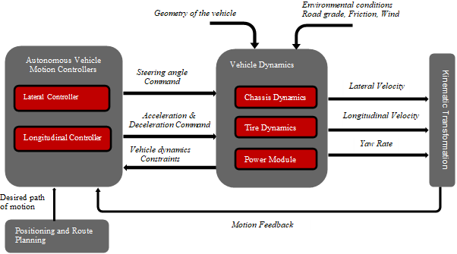

More about the challenge and the targets.

## Thesis Overview

Brief description of all the thesis contents.

# Background and Literature Review

## Planning and control in Autonomous Vehicles

### Global Path Planning

### Decision making in AV

### Control and vehicle maneuvering

## Planning and control approaches

### Classical Rule Based approaches

Describe classical approaches

### Optimization Based approaches

### Learning Based approaches

Describe learning based approaches

#### Imitation Learning

#### Reinforcement Learning

# Highway Lane Changing for Autonomous Vehicles.

## Lane Changing Approaches

There are several key challenges that autonomous vehicles (AVs) must overcome to navigate on highways safely and effectively. Some of these include:

Lane keeping and lane changing:

AVs must be able to accurately detect and stay within the lanes on the highway, as well as safely and smoothly change lanes when necessary. This requires robust perception and localization capabilities, as well as sophisticated control algorithms.

Lane keeping and lane changing are important capabilities for autonomous vehicles (AVs) to have when driving on highways. These tasks can be challenging for AVs because they require the vehicle to accurately perceive and understand its environment, as well as make safe and smooth driving decisions. One of the key challenges in lane keeping is accurately detecting and tracking the lanes on the road. This is typically done using a combination of cameras, lidar, radar, and other sensors, which can detect the edges of the lanes and other road markings. The sensor data is then processed using computer vision algorithms that can identify the lanes and track their position over time.

Once the lanes have been detected and tracked, the AV can use control algorithms to keep the vehicle within the lanes. This typically involves using a combination of steering, braking, and acceleration commands to control the position and speed of the vehicle. The control algorithms should be robust enough to handle different road conditions and lane geometry, such as curved roads and merging lanes.

Lane changing is similarly challenging and requires the AV to have a precise understanding of its environment and the intentions of other vehicles on the road. The AV must detect and track the other vehicles and use this information to plan and execute safe lane changes. This typically involves assessing the speed, position, and trajectory of the other vehicles, and using this information to calculate safe gaps for lane changes. The AV must also take into account the surrounding traffic and any potential hazards, such as construction or emergency vehicles.

To ensure safety, the decision-making and control algorithms for lane keeping and lane changing are typically tested extensively in simulation and on test tracks before being deployed on real roads.

In general, Lane keeping and lane changing are complex task for autonomous vehicles, it is important to note that many companies are testing their AVs on different geographical locations to adapt and enhance their systems to work optimally based on different weather conditions, and traffic flow.

1. Handling high-speed driving: AVs must be able to safely and comfortably drive at high speeds, which can be challenging due to the large forces involved. This requires the vehicle to have precise and responsive steering, braking, and acceleration capabilities.
2. Handling merging and merging traffic: AVs must be able to safely enter and exit highway on-ramps and off-ramps, as well as navigate through merging traffic. This requires the vehicle to have an accurate understanding of its environment and the intentions of other vehicles on the road.
3. Handling different weather and lighting conditions: AVs must be able to operate in a wide range of weather and lighting conditions, including rain, fog, snow, and darkness. This requires the vehicle to have robust perception capabilities that can handle occlusions and reflections caused by different weather and lighting conditions.
4. Handling emergency and unexpected events: AVs must be able to handle emergency and unexpected events, such as sudden braking safely and smoothly by other vehicles, lane closures, and construction zones. This requires the vehicle to have an accurate understanding of its environment and the ability to make rapid and safe decisions.
5. Handling traffic laws and regulations: AVs must be aware and follow all traffic laws and regulations. which can vary from state to state, country to country and region to region. They should also be designed to handle specific situations such as emergency vehicles, school buses and many more.

Overall, developing AVs that can safely and effectively navigate on highways requires a combination of advanced sensor technologies, sophisticated perception and decision-making algorithms, and rigorous testing and validation.

## Rule Based Lane change decision making.

### Lane change problem formulation

### Static Obstacle Lane Change

### Dynamic Obstacle Lane Change

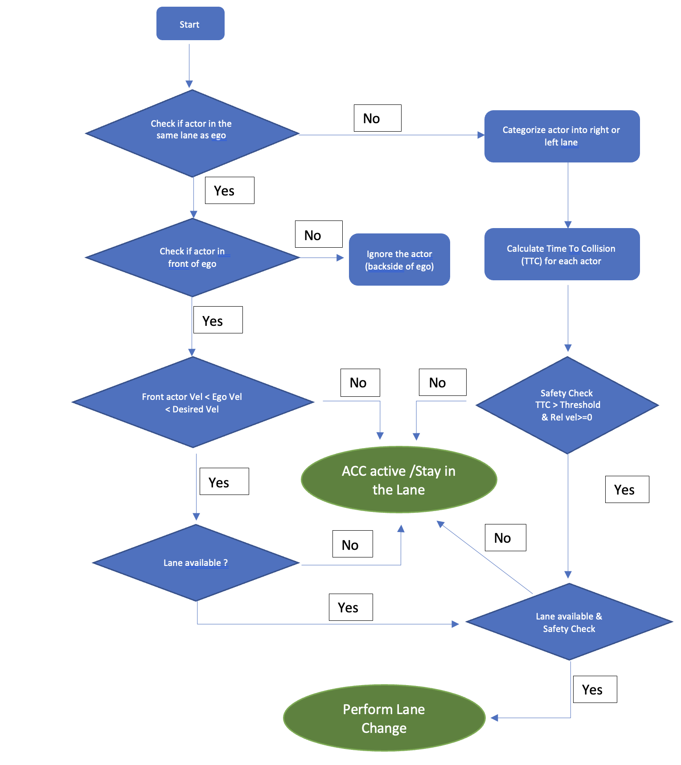

## Lane Change Trajectory Generation

# Lane Change in the presence of Icy/ Snowy Conditions

Lane changes for autonomous vehicles in challenging weather conditions, such as heavy rain, snow, or fog, can be a complex task. Autonomous vehicles rely on a variety of sensors, such as cameras and LIDAR, to detect and interpret the road and other vehicles. In challenging weather conditions, these sensors can be affected by reduced visibility, glare, and reflections.

To safely perform lane changes in challenging weather conditions, autonomous vehicles must have the following capabilities:

1. Weather-adaptive sensors: The vehicle's sensors must be able to detect and track objects in challenging weather conditions and be able to adjust their performance accordingly.
2. Weather-adaptive control systems: The vehicle's control systems, such as the steering and braking systems, must be able to respond quickly and accurately to the road conditions, adjusting the vehicle's trajectory and speed as necessary to maintain stability and avoid skidding.
3. Weather-adaptive software algorithms: The vehicle's software must be able to process sensor data and adjust the vehicle's behavior in real-time to ensure a safe journey. This includes adjusting the vehicle's speed, trajectory, and following distance based on the road conditions.

It's worth mentioning that the implementation of these capabilities is a challenging task, and some companies are still working to improve the system to work under all weather conditions.

Top of Form

Some of the critical parameters to analyze the lane change behavior in challenging weather conditions can be:

1. Traction control: Autonomous vehicles must have a reliable traction control system to maintain a stable and safe trajectory on slippery roads. This includes monitoring wheel slip and adjusting the engine's power output to prevent skidding.
2. Speed: The vehicle's speed must be adjusted based on the road conditions to ensure safe lane changing. On slippery roads, the vehicle should be driven at a lower speed to increase stability and reduce the risk of skidding.
3. Steering and braking: The vehicle's steering and braking systems must be able to respond quickly and accurately to the road conditions. This includes adjusting the steering angle and brake pressure to maintain control of the vehicle and avoid skidding.
4. Sensor performance: The vehicle's sensors, such as cameras and LIDAR, must be able to accurately detect and interpret the road and other vehicles in the presence of adverse weather conditions, such as heavy rain and fog.
5. Road information: The vehicle's software must have access to accurate and up-to-date information on the road conditions, such as the location of standing water or ice, to adjust its behavior and ensure a safe journey.
6. Vehicle dynamics: the vehicle's dynamics, such as the vehicle mass, center of gravity, and tire-road friction, must be taken into account when making lane changes on slippery roads.
7. Emergency braking: the vehicle must be able to apply emergency braking when it detects a potential collision or hazardous situation.

Overall, lane changing for autonomous vehicles in slippery road conditions requires a combination of advanced sensors, control systems, and software algorithms to safely navigate the vehicle in these challenging conditions.

# Artificial Potential Field Approach for Highway Lane Change

## Artificial Potential Fields (APF):

Artificial Potential Fields (APF) is a method used in robotics for motion planning and obstacle avoidance. It is based on the concept of creating a virtual potential field around the robot, which guides it towards the goal while avoiding obstacles. The method involves defining a potential function that represents the forces acting on the robot in its environment, including attractive forces towards the goal and repulsive forces away from obstacles. The resulting force field is then used to guide the robot's motion.

The basic concept of APF is to define an attractive potential field around the goal location, such that the robot moves towards it. The potential field is represented as a scalar function, which decreases as the robot gets closer to the goal. At the same time, a repulsive potential field is defined around obstacles, such that the robot moves away from them. The repulsive potential field is also represented as a scalar function, which increases as the robot gets closer to the obstacles. The resulting force field is the superposition of these two potential fields, which generates a vector field that guides the robot towards the goal while avoiding obstacles.

The attractive potential is typically represented by a Gaussian function centered on the goal location, while the repulsive potential is represented by an inverse distance function, which increases as the robot approaches the obstacle. The resulting potential function is then used to calculate the gradient of the field, which provides the direction of motion for the robot.

One of the advantages of the APF method is that it is computationally efficient and can handle complex environments with multiple obstacles. However, it can suffer from local minima where the robot gets stuck in a suboptimal position due to the potential field. Various modifications and enhancements have been proposed to address this issue, such as adaptive and hybrid potential fields.

## APF Analogy:

An analogy for the Artificial Potential Fields (APF) method is the way a ball moves on a surface with hills and valleys. Imagine a ball rolling on a surface with hills and valleys. The goal is to move the ball from its initial position to a target position while avoiding obstacles along the way.

The surface can be thought of as a potential field, where the hills represent obstacles, and the valleys represent the goal. The ball represents the robot or vehicle, which moves under the influence of the forces acting on it. In this analogy, the force acting on the ball is equivalent to the gradient of the potential field.

The APF method works by defining an attractive potential field around the target position, which pulls the ball towards the goal. At the same time, a repulsive potential field is defined around the obstacles, which pushes the ball away from them. The resulting force acting on the ball is the sum of these two potential fields, which guides the ball towards the goal while avoiding obstacles.

The strength of the repulsive potential field depends on the distance between the ball and the obstacles. When the ball is close to an obstacle, the repulsive force is strong, which pushes the ball away from the obstacle. As the ball moves away from the obstacle, the repulsive force decreases, and the ball moves towards the target position.

Similarly, in APF method, the strength of the repulsive potential field depends on the distance between the robot or vehicle and the obstacles. The attractive potential field is centered on the target position, and the repulsive potential field is centered on the obstacles. The resulting force acting on the robot or vehicle is used to guide it towards the goal while avoiding obstacles.

## APF Drawbacks:

While Artificial Potential Fields (APF) is a popular method for motion planning and obstacle avoidance in autonomous vehicles, it has some drawbacks that need to be considered. Some of the drawbacks of APF for autonomous vehicles are:

1. Local minima: One of the main drawbacks of APF is that it can suffer from local minima, where the robot or vehicle can get stuck in a suboptimal position due to the potential field. This happens when the robot or vehicle gets trapped between repulsive forces from multiple obstacles, which makes it difficult to find a clear path to the goal position. Various modifications and enhancements, such as adaptive and hybrid potential fields, have been proposed to address this issue.
2. Sensitivity to potential function parameters: The performance of APF is sensitive to the choice of parameters for the potential function. If the parameters are not chosen carefully, the robot or vehicle may collide with obstacles or take longer routes to reach the goal position.
3. Limited ability to handle complex environments: APF can struggle in highly complex environments with multiple obstacles, as the potential function may become too complex to be effectively used for motion planning. In such cases, other methods such as probabilistic algorithms or machine learning approaches may be more suitable.

## Improved APF for lane changing in autonomous vehicles in the presence of low friction surfaces:

APF can be used in autonomous vehicles for lane change maneuvers. Lane change maneuvers involve detecting an opening in the adjacent lane and then changing the lane while avoiding collisions with other vehicles. The APF method can help in generating a collision-free path for the lane change maneuver by creating a virtual potential field around the vehicle.

To implement APF for lane change maneuvers, the attractive potential field is towards the goal position. and the repulsive potential fields are centered around the other vehicles. The repulsive potential fields should be strong enough to keep the vehicle away from the other vehicles, but not too strong that it becomes difficult to find a path through the potential field.

### Design requirements:

Design requirements for the application of Artificial Potential Fields (APF) in lane changing for autonomous vehicles include the following:

1. Object detection: The first requirement is to have a reliable object detection system that can detect and track other vehicles in the surrounding lanes. This system should be able to accurately estimate the position, velocity, and direction of the other vehicles.
2. Sensor fusion: The next requirement is to have a sensor fusion system that combines data from multiple sensors, such as lidar, radar, and cameras, to provide a comprehensive view of the environment.
3. Performance and efficiency: The APF method should be designed to achieve the desired performance and efficiency in terms of lane change time, smoothness, and energy consumption.
4. Robustness: The APF method should be robust to uncertainties in the environment, such as inaccurate object detection or sensor noise. This can be achieved by using adaptive potential fields or by incorporating probabilistic models into the algorithm.

In this thesis, we assume a perfect object detection and other environment information from the perception system.

### Improved Potential Fields:

There are different factors to consider for an autonomous vehicle to drive on a highway and reach its final goal. Firstly, the vehicle should maintain the center of the lane and avoid changing lanes unnecessarily. Since there is a large difference in the longitudinal and lateral speeds, the longitudinal and lateral safety distances from the other vehicles are different. The dynamic characteristics of the ego and other vehicles play a critical role in maintaining the safe distance. In this study, we mainly focus on the highway lane changing scenarios in the presence of snowy/Icy conditions. Hence the effect of friction coefficient is also incorporated in the potential field functions.

The proposed total potential field $U_{total}$ is the sum of various potential fields such as $U_{road}, U_{target}, U_{vehicle}$. Each potential field is discussed below in detail.

### Target Potential $(U_{target})$:

The target potential is a virtual attractive force that pulls the vehicle towards the desired destination. This attractive potential is strongest at the goal location and gradually diminishes as the vehicle is away from the target.

The target potential can be defined mathematically as a scalar function that represents the strength of the attractive force at any given point in the potential field. This function is often chosen to be a decreasing function of distance, which ensures that the force becomes weaker as the vehicle moves away from the target.

The target potential is an essential component of the APF algorithm because it guides the vehicle towards the desired destination while avoiding other actors. The repulsive potentials around the actors act as a barrier that prevents the vehicle from colliding with them, and the attractive potential towards the target ensures that the vehicle reaches its destination.

In this work, a linearly decreasing potential is considered with the maximum potential value at the start location and the minimum value of potential at the target location. The below equation describes the target potential.

$$U_{target}\left(x,y\right)= -K_{target}(x-x_{target})$$

Consider a start position for the ego vehicle as $x=0$ and the goal position as $x=950.$

For two different values of $K_{target}$, the target potential field can be visualized in the figures below:



Increasing the value of $K_{target}$ increases the steepness of the potential field towards the target. The right value of $K_{target}$ is be obtained by modifying the potential field such that the ego vehicle can reach its target in presence of other actor potentials.

The top view of the target potential along the road is shown in the figure below:



Lowest potential (Target)

Highest potential (Start)

### Road Potential $(U_{road})$:

For the lane maintenance and departure in autonomous driving, the goal of the road potential is to keep the vehicle within the lane by creating a repulsive force that pushes the vehicle back towards the center of the lane when it deviates a little. The road potential must also make sure that the vehicle can change the lane if necessary.

To achieve this, road edge potential ( $U_{edge})$ is formulated, where the road boundaries are represented by high repulsive potentials. These repulsive potentials increase in strength as the vehicle moves closer to the road edges, creating a force that pushes the vehicle back towards the center of the lane. A slight repulsive potential is also applied on the road centerline ($U_{center}$) which is ought to work with the road edge potential. The combination of these two potential functions helps the vehicle maintain its lane and change the lane if necessary. The road edge and centerline potential are represented on the road marking as shown in the figure below:

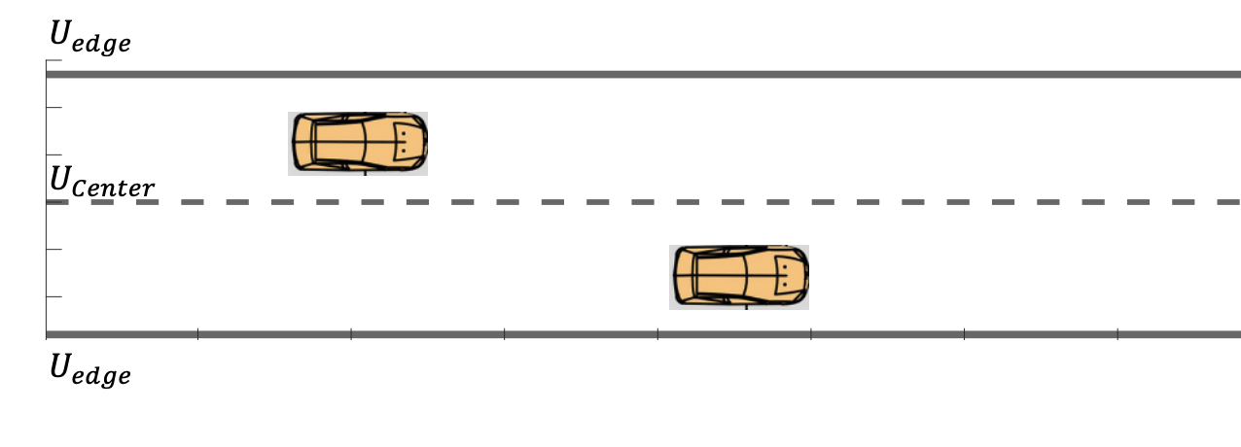

In this study, exponential functions of the lateral distance from the road edges are considered to formulate the road edge potential. The left and right edge potentials are defined as:

$$U_{edge_{l}}=k_{edge}\left(-e^{\left(y-y_{left}\right)} \right)$$

$$U_{edge_{r}}=k_{edge}\left(-e^{\left(y-y_{right}\right)} \right)$$

Here $k_{edge}$ is the parameter to adjust the magnitude of the repulsive potential of the road edge.

$y_{left}$ and $y_{right}$ are the left and right road boundary values.

Combining the two road edge potentials, the resulting overall potential is shown in the figure below.



Considering a gaussian function, the centerline potential can be formulated as,

$$U_{center}=K_{c}e^{-\frac{d^{2}}{2{}^{2}}}$$

Here $K_{c}$ is the coefficient of the road centerline, $d$ is the distance from the ego vehicle to the road centerline, $σ$ is the convergence coefficient of road width.

Combining the road edge potential and the centerline potential, we obtain the total road potential.

$$U_{road}={(U}_{edge_{l}}+U_{edge_{r}})+U_{center}$$

For $K_{c}=35, σ=1$ the total road potential field is shown in the figure below.



The top view of the road potential is shown below:



For different values of $K_{c}$, the centerline potential is changed as shown in the figures below:



Increasing the coefficient of road centerline increases the centerline potential. A right choice of $K_{c}$ is required to formulate the overall road potential to follow the lane and do lane changes if necessary.

### Vehicle Potential $(U_{vehicle})$:

The potential field of an obstacle vehicle is a repulsive potential field which keeps the ego vehicle at a safe distance from the obstacle. The vehicle potential is formulated in a way such that the ego vehicle maintains a safe distance by either following the vehicle or changing its current lane to the other.

A two-dimensional Gaussian distribution approach is used since it allows to model the repulsive force of an obstacle vehicle as a smooth and continuous function, rather than a sharp potential barrier. This can make it easier for the ego vehicle to navigate around the obstacle vehicle and follow a smoother path.

The vehicle potential defines the behavior of the ego vehicle when it approaches the vehicle. In this study, the vehicle potential incorporates the safety by taking the following factors into effect:

1. The relative velocity between the ego and the vehicle
2. The size and type of the vehicle
3. The friction coefficient between the ego vehicle and the road surface.

Vehicle potential: based on absolute velocity and relative velocity, friction coefficient and the size of the obstacle

High absolute and relative velocity - high obstacle potential

Low friction coefficient – high obstacle potential



### 

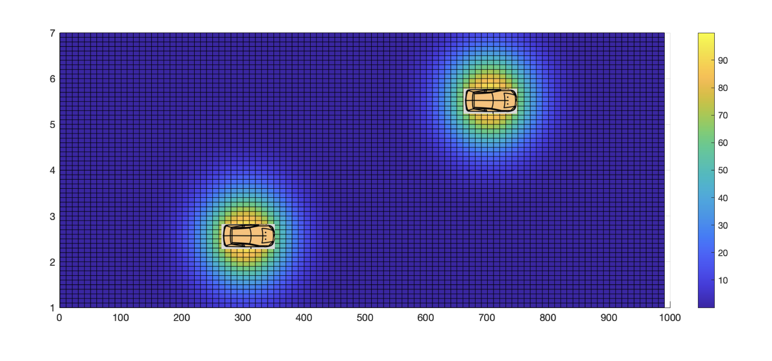

The road potential combined with the vehicle potential is shown in the figure below:

The vehicle obstacle potential field (static) combined with the road and the target potential can be visualized as shown in the figure below:



# 

# Verification and Validation

## Overview

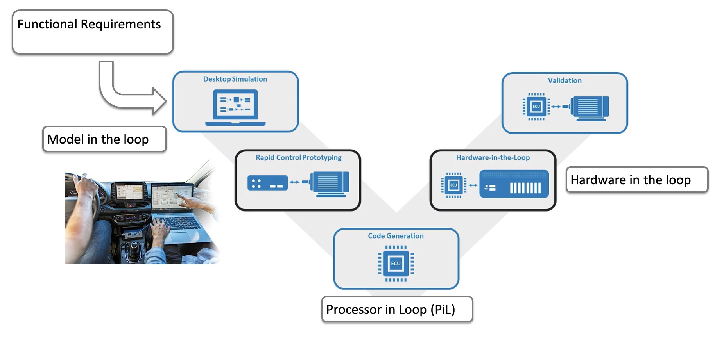

## Model in loop V&V

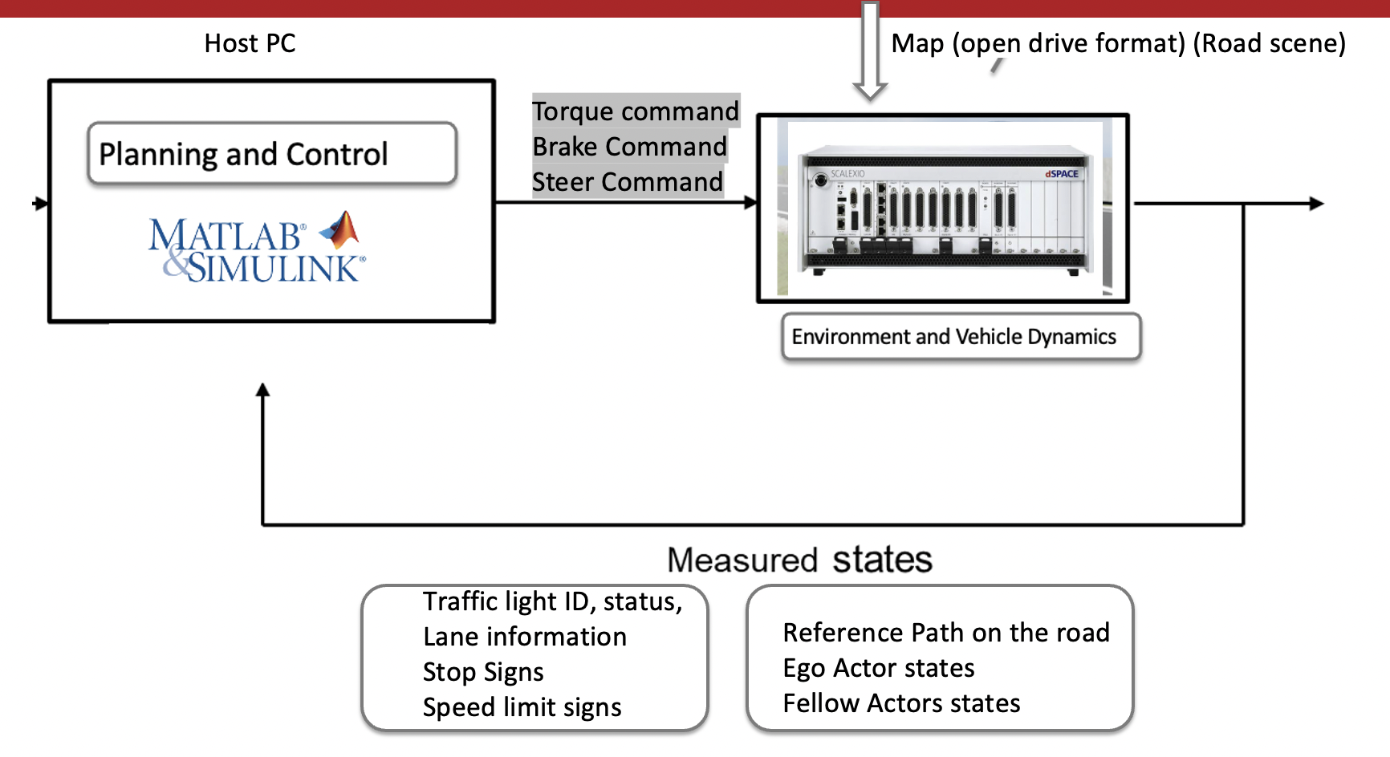

### Overview and setup

## Hardware in loop V&V

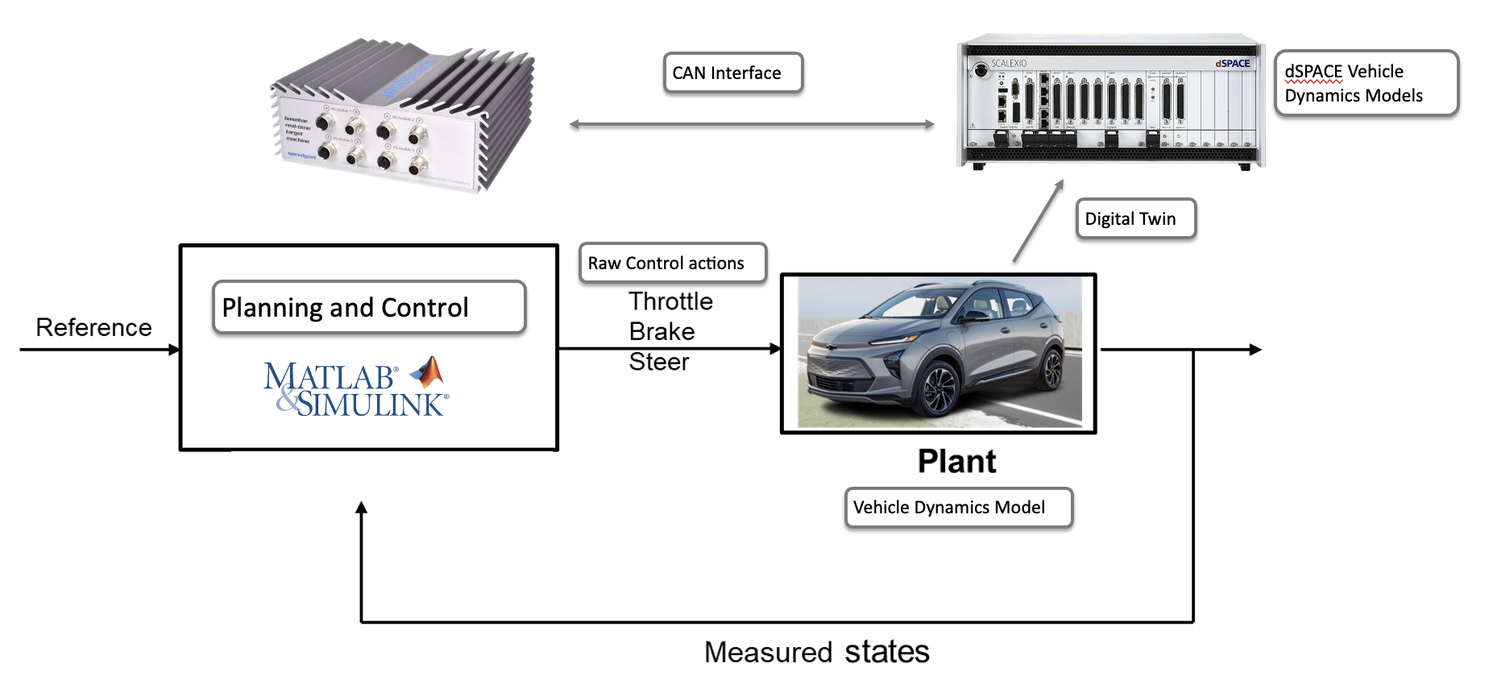

### Overview and setup